**Lab 1b Creating a Windows XP SP2 Attack Victim Using VMWare.**

**Caveat**

Be sure to read the lab in its entirety before stating this or any lab in the course! Skipping a step in any part of the lab will cause the lab to fail. Trying to blow through this lab will result in epic failure! Slow and steady wind the race.

**Requirements:**

1. Windows XP Prebuilt Image
2. VMWare Workstation Player or Workstation Pro installed
3. CPU that supports Virtualization.
4. 8GB of RAM preferred. (4 GB of RAM will Suffice but is not optimal)
5. At least 10 GB of free hard drive space. (An external hard drive or thumb drive can also be used as storage)

**Using Other Hypervisors**

For all the gunslingers in the course, if you are using some other hypervisor to create your virtual lab environment, you are good to go. No need to check with the instructor.

This lab, will walk through the creation and installation of a Windows XP inside VMWare using a prebuilt Windows XP OVF file. Windows XP will function as our victim machine for all labs going forward.

**How much time to allocate for this lab**

The whole process may take 45 minutes to complete depending on the specifics of your own situation, i.e., computer, internet connection speed, and so on.

As the lab begins, students will be taken through the download process for any downloads. All software has been verified to be malware and crapware free.

**Begin the lab!**

**Download the Windows XP OVF file.**

This will take you a Dropbox folder. Go to the upper right and open the context menu. From the options, find Download, right click, and select **Copy Link Location**.

[Open Dropbox folder here!](https://www.dropbox.com/s/xmtzf2j5jihdimd/Windows%20XP%20Target%20-%20VMWare.zip?dl=0)

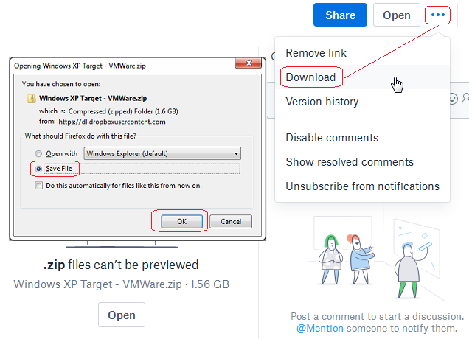

Remember where you save the file!

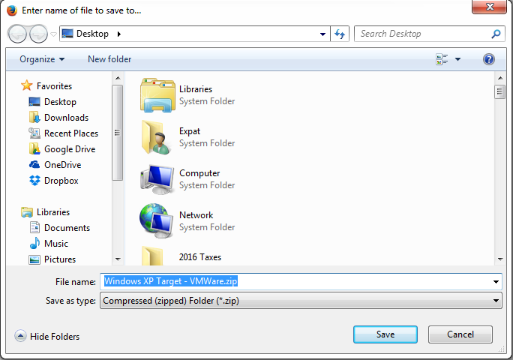

Once the file has completed downloading, browse to the download location, find the downloaded file and extract to the same location. Open the extracted folder and inside.



Open the extracted folder. X2 click the OVF file and the importation process into VMware will being. If not, just click on the Open a Virtual Machine, browse to the OVF file, and allow the importation wizard to take over.

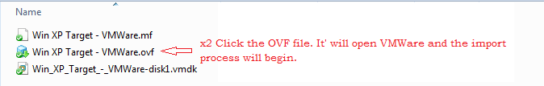

If you wish to save you virtual disk to some other location, you can click on the browse button to do so. Click Import.

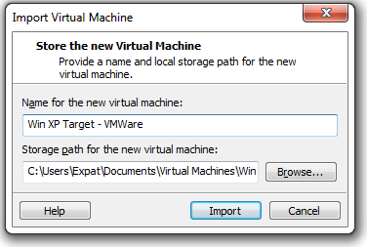

The importation process starts.

From your Left Console Window, find the Win XP Target – VMWare and click the green start button.

This VM comes with VMWare tools preinstalled. This is a M$ Windows XP VM designed for developers created and released by Microsoft. Other VM for Windows 7, 8 and 10 are also available for developers.

Do not fix any of the security advisory prompts! This a victim for the remaining Windows XP labs, we want it to remain vulnerable.

The machine comes with a thirty-day trial but can be rearmed for another 30 days’ numerous time by just following the direction on the desktop background. The command circled in read is ran from the command prompt.

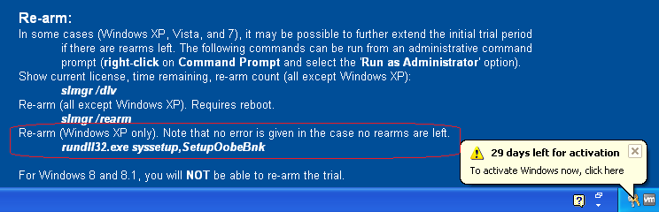

To shut down your Windows XP, click on the start button, select Turn of Computer

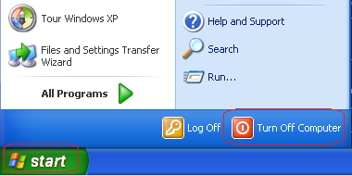

On the next screen, select Turn off.

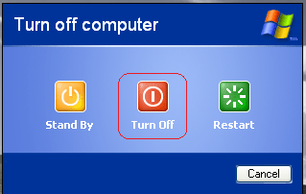

If prompted about a fragmented disk, affecting the virtual machines performance, say OK and follow the instructions.

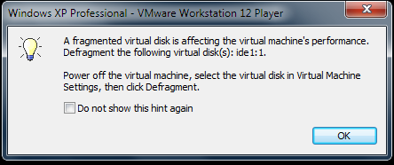

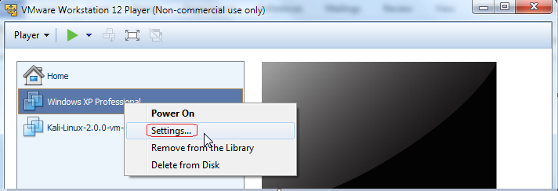

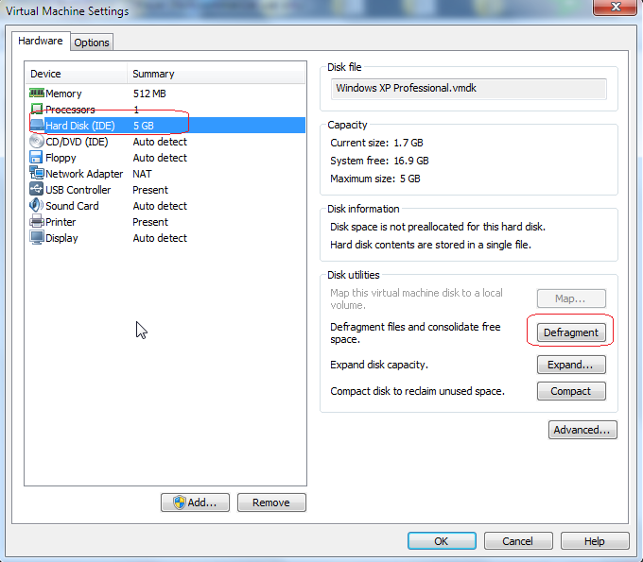

If you’re not happy with the install of the VM and would like to start over…

To remove the VM from the VMWare Management console, right click on the name of the VM and select **Delete from Disk.**

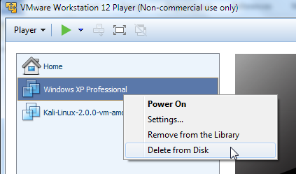

End of Lab!